Git commands

cd C:\Users\admin\Desktop\git learning

# Basic linux cmds

**diff file1.php file2.php**

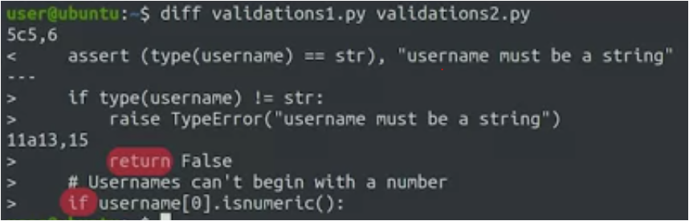

> line is removed in first file

< line is added in second file

5**c**56 - c means changed

11**a**13 - a means added

**diff –u file1.php file2.php**

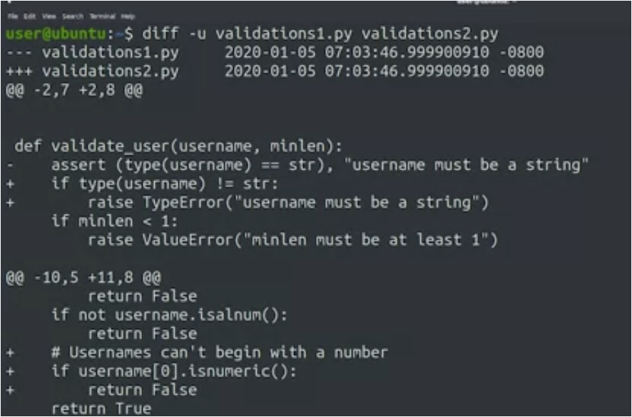

**wdiff** to see words changed in docs

other examples : **meld, KDiff3, vimdiff**

**diff –u oldfile newfiel > change.diff**

it generates a diff file

**PATCH**

**patch filename.php < changes.diff**

# GIT basics

**git config** -–global user.email “mail”

**git** **config** -–global user.name “name”

**git** **init** – to initialize a new git

**git** **add <filename>** - to add new file

**git add -A** stages All

**git add .** stages new and modified, without deleted

**git add -u** stages modified and deleted, without new

**git** **status** - to view status

**git commit** – to commit changes

**git commit –m ‘commite message’** - to commit in single line

**git commit –a ‘commite message’** - to commit without staging

**git config –l** – to view current user

**git log** – to view history of commit message

**git log --stat** – to view number of insertion and deletions in the git

**git log –graph –oneline** – to view history of commit message in oneline and with graph

**git show <id>** - to view the changes in the commit

**git diff** – to view changes in the files

**git diff –staged** – to view changes in the staged files

**git rm <filename>** – to remove files from git

**git mv <filename>** – to move or rename files

**(**ONLY IN BASH**)echo “filename” > .gitignore –** to move files to .gitignore

**git checkout <filename>** – to remove changes made in the file(BEFORE STAGING)

**git checkout –p <filename>** – to remove changes made in the file snap by snap(BEFORE STAGING)

**git reset HEAD <filename>** – to remove changes made in the file(AFTER STAGING)

**git reset HEAD –p <filename>** – to remove changes made in the file snap by snap(AFTER STAGING)

**git commit –amend** – to update a last commit (NOT TO USE THIS PUBLIC REPOs )

**git revert HEAD** – to revert a commit and moving back to last commit

**git revert <ID>** – to revert a commit and moving back to given commit ID

**git branch** – to display all branches

**git branch “branch name”**– to create a new branches

**git checkout “branchname”**– to switch btwn branches

**git checkout –b “branchname”**– to create a new branches and switch branch

**git branch –d “branch name”**– to delete branches

**git branch -D “name”** - Forcibly deletes the branch

**git merge “branch name”**– to merge branch to master

**git merge --abort**– to revert merge

**git** – to

**git** – to

**git** – to

**git** – to

**git** – to